Grove - Collision Sensor

|  |
| --- |
| **Contents**   [[hide](javascript:toggleToc())]   * [1 Introduction](http://www.seeedstudio.com/wiki/Grove_-_Collision_Sensor#Introduction) * [2 Features](http://www.seeedstudio.com/wiki/Grove_-_Collision_Sensor#Features) * [3 Application Ideas](http://www.seeedstudio.com/wiki/Grove_-_Collision_Sensor#Application_Ideas) * [4 Usage](http://www.seeedstudio.com/wiki/Grove_-_Collision_Sensor#Usage) * [5 Resources](http://www.seeedstudio.com/wiki/Grove_-_Collision_Sensor#Resources) * [6 Support](http://www.seeedstudio.com/wiki/Grove_-_Collision_Sensor#Support) |

Introduction

This sensor detect whether any collision movement happens. It will output a positive pulse when gets collided. To make the signal more reliable and neat, we added neccessary exterior circuit to reduce the noise. So normal shaking will not cause any output. The max detectable frequency of collision is 20Hz.

[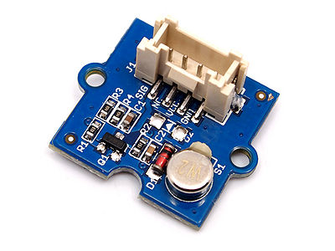](http://www.seeedstudio.com/wiki/File:Grove_%E2%80%93_Collision_Sensor_photo.jpg)

Features

* Easy to use
* Suitable for direction-unsensitive applications
* RoHS/WEEE lead-free compliant

Application Ideas

* Collision detection
* Protective system for fragile devices

Usage

Here is an example of Collision Sensor to control an LED. Evert time the sensor get collided, the LED lights up.  
1. Connect the module to the Digital port 2 of Grove - Basic Shield using a Grove cable and connect an LED to Pin 13.  
2. Plug the Grove - Basic Shield into Arduino.  
3. Connect Arduino to PC by using a USB cable.   
(图片)   
4. Copy and paste code below to a new Arduino sketch. And upload it to your Arduino. Please click [here](http://www.seeedstudio.com/wiki/Upload_Code) if you do not know how to upload.

/*****************************************************************************/

// Function: The collision sensor triggers the LED on and off.

// If the sensor triggers, the LED is on for 2s and then it is off.

// Hardware: Collision sensor

// Arduino IDE: Arduino-1.0

// Author: Frankie.Chu

// Date: Jan 11,2013

// Version: v1.0

// by www.seeedstudio.com

//

/*******************************************************************************/

#define LED 13 //the onboard LED of Arduino or Seeeduino

#define COLLISION_SENSOR 2//collision sensor is connected with D2 of Arduino

void setup()

{

pins_init();

}

void loop()

{

if(isTriggered())

{

turnOnLED();

delay(2000);

}

else turnOffLED();

}

void pins_init()

{

pinMode(LED,OUTPUT);

turnOffLED();

pinMode(COLLISION_SENSOR,INPUT);

}

boolean isTriggered()

{

if(digitalRead(COLLISION_SENSOR))

{

delay(50);//Debounce 50 milliseconds

if(digitalRead(COLLISION_SENSOR))

return true;//the collision sensor triggers

}

return false;

}

void turnOnLED()

{

digitalWrite(LED,HIGH);//the LED is on

}

void turnOffLED()

{

digitalWrite(LED,LOW);//the LED is off

}

5. Now you can check the status of LED. The LED should light up every time you use a hard object to crash the sensor really nice.

Resources

[File:Grove - Collision Sensor eagle file.zip](http://www.seeedstudio.com/wiki/File:Grove_-_Collision_Sensor_eagle_file.zip)